Samsung Galaxy TAB Active 4 Pro 5G

Type of device: Tablet
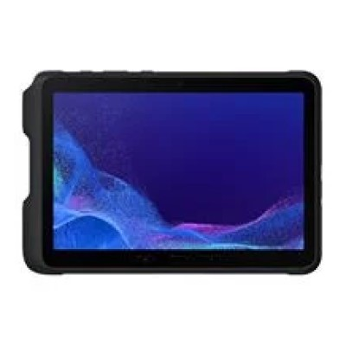

Actual Display Size : 10.1
Operating System : Google Android
Version Number : 12
Network Capability : 3G,4G,5G
Year of Release : 2022
Average Price : $1199 as of 11 01 2022
Internet Access : Wi-Fi and Mobile Broadband

Accessibility Features:

Cognitive
- Additional Instructions
- Copy and Paste
- Flicker Free Display
- GPS
- Photo Telephone List
- Screen Timeout Disabled
- Simple Instructions
- Simple Reminders
- Simplify Display
Voice Notes

Hearing Impairment and Deaf
- Allows for sign language communication
- Bluetooth or Wi-Fi
- Closed Captioning
- Front Facing Camera
- Hearing Aid Microphone Coupling
- Hearing Aid Telecoil Coupling
- Text Messaging/SMS
- Vibrating Alerts - Adjustable
- Video Communications - Two-way
Visual Alerts - Incoming Calls

Vision
- Accessibility APIs supported
- Battery Alert - Audible
- Bluetooth or Wi-Fi
- Braille Display Support
- Brightness Adjustable
- Dictation / Speech-to-Text
- High Contrast Mode
- Personalised Shortcuts
- Power Cue
- Screen Magnifier
- Screen Reader
- Text Size Adjustable
- Text Style Adjustable
- Voice Control /Personal Assistant
Voiced Menus

Speech
- Allows for sign language communication
- Bluetooth or Wi-Fi
- Messaging Options - Email
- Messaging Options - IM
- Messaging Options - MMS
- Predictive Text
SMS Personalisation and Reuse

Physical
- Automatic Answer
- Bluetooth or Wi-Fi
- Dictation / Speech-to-Text
- Gesture Based Navigation
- Headset - plug connected
- Predictive Text
- Reduced hand movement option
- Speaker-phone option
- Stylus or Prosthetic Device support
- Switch control option
- Visible Focus Indicators
- Voice Control / Personal Assistant
- Voice Recognition for Accessing Features
Voice Recognition for Dialling

How and where to get it from?
You can buy this tablet from Telstra, Samsung, and other retailers.

More information is available on:
Samsung Galaxy TAB Active 4 Pro 5G webpage
Samsung Galaxy TAB Active 4 Pro 5G Support webpage

